Proposal introduction & rationale

This project is the first step towards the creation of a novel solution to market failures that can serve as the foundation for a thriving, truly sustainable blue economy. The proposed solution, a digital platform for coastal stakeholders, would address the market failures inherent in supply and demand for threshold quasi-public goods in the context of incomplete information. This digital platform would enable the aggregation of dilute supply of and demand for environmental information; as well as enable the collection, exchange, and management of this information and the contracts associated with it. This project would develop and empirically validate a theoretical model of this platform. This project and the eventual digital platform has the potential to help solve systemic problems present within current economic structures found around the world, especially within developing coastal economies.

The world’s coasts currently generate 68% of global GDP, and are home to 40% of Earth’s population [1]. Seafood alone provides 20% of protein intake globally, over 70% for some communities [2]. Unfortunately, our coasts face increasingly numerous and severe threats that are being exacerbated by the flawed incentive structures of our blue economy. Worldwide, 30% of seafood goes unreported; two-thirds of fisheries are overfished[3]; over $1 billion[1] is lost to harmful algal blooms (HABs) each year; damages from flooding, severe weather, and tropical cyclones totaled $3.1 trillion from 2010 to 2019 [4]; and projected ocean acidification damages will reach $1 trillion by the end of the century [5]. The blue economy needs more frequent, accessible, and useable high-quality information[2] to tackle these threats, but this information continues to require too much money, time, or technical expertise to reach the scale needed, especially for developing nations[3] [6]. The hyper-focus of blue economy initiatives on specific problems with little, if any, coordination and without considering the entire system has not helped, either. Thus, inefficient, short-sighted, misinformed decision-making is rampant among governments, private business, and individual citizens. This inefficiency wastes public and private capital, with huge losses in potential revenue.

These problems are perpetuated by multiple market failures that decouple decision-making from the environment upon which the blue economy ultimately depends. The incentives in our blue economy are arranged such that externalities like free-ridership are rampant, making it highly unlikely for any single, already-established entity to profit from tackling these market failures. Why would Government/Company A bother to spend time and money on issue Z when it could just let Government/Company B fix it while still reaping the benefit? Hence, existing institutions have limited scope, and even act as obstacles to addressing systemic issues (i.e., rent-seeking and self-preservation behavior). This same aversion to fixing the overarching system also discourages investment in valuable environmental information, the systems necessary for gathering this information, and the activities dependent upon it. The return on investment (ROI) is too low. In other words, the marginal gain to a *single* entity that results from incorporating environmental information into a business/management decision is frequently dwarfed by the investment of time, effort, and/or money required to produce this environmental information. However, there are countless situations where the *collective* gain is exponentially greater than the necessary investment. The structure of the economic system itself needs to be reimagined so as to encourage collaboration; and integrated, holistic, long-term solutions.

Enter this project. We propose a revolutionarily new way of transacting within the blue economy via a digital platform. The platform would consist of a network whose nodes are the members of our blue economy, connected to each other via digital pipes through which information and compensation can flow. The openings of these pipes would be governed by codified contracts, customized to the needs of each member, with the dynamic arrangement of these pipes contingent upon the ever-changing aggregate supply and demand for these needs within the network. Through the platform, transactions can occur between groups, rather than individuals, on a case-by-case basis. Plus, due to the codification of contracts, transactions and terms and conditions enforcement can be automated. And all of this activity can be recorded in an accessible, immutable, traceable, and transparent ledger; thus ensuring members and their transactions are trustworthy. This project aims to develop a theoretical model of this platform, and then empirically validate this model via a lab-based experiment.

## Literature Review

This project will contribute to existing literature on common agency under adverse selection, moral hazard, and threshold public goods. Contract theory uses constrained optimization to find the optimal agreements between (a) principal(s), the contract proposer, and (an) agent, the potential contract acceptor. Contracts are formed under asymmetric information which is often attributable to adverse selection (where agent type is unknown), or moral hazard (the effort the agent puts in is unknown), or both. Although common agency under adverse selection has been widely studied[4], especially in the case of one principal and one agent [20-22], few papers have focused on situations with multiple principals and one agent. Yet, this situation is common: lenders can simply be resource constrained [29], there could be strategic informational advantages, or it could be a consequence of the lowered cost of monitoring an agent a principal incurs when monitoring is shared [34].Importantly, even when inefficient[5], agents will often still borrow from several principals, as is common in the blue economy where grant-funding proliferates. Due to adverse selection, moral hazard, competition, and lack of coordination, grantors design contracts not only to incentivize cooperation by the agent through monitoring and transfers, but also to out-compete the offers of other grantors [25,26]. With adverse selection alone, the grantor (principal) extracts inefficient levels of rent from the grantee (agent), as well as contractual externalities due to the interactions between the contracts offered by the various entities –including grantor(s)– engaging with the grantee[6]. With moral hazard, the importance of monitoring arises as the grantee has the incentive to underperform. Khalil 2007 formally examines three scenarios where multiple principals attempt to obtain income from a privately informed agent, a context reminiscent of the funding relationships found in our blue economy. In the first scenario, centralized monitoring and coordinated contracting, contracts are optimal for all parties. In the second, centralized monitoring and uncoordinated contracts, each principal derives a positive externality from the other principal’s contract, resulting in excessive monitoring. And in the third, which lacks both centralized monitoring and contract coordination, free riding between principals leads to a collapse of monitoring for high profit agents, leaving all parties worse off [20,21,27,28,36].Unfortunately, within the blue economy, this third scenario is the most common. For example, in highly resource constrained contexts like those frequently found in coastal communities, transaction costs prevent centralization and cooperative contracting, significantly impacting the resultant contracts, or even eliminating them entirely. Importantly, these transaction costs arise not just from monitoring expenditures, but from contractual externalities. Coordination is necessary to counteract grantors’ natural disregard of the impact of their grant relationships (level and structure of investment, monitoring, and exercise of control rights) on the returns of the other grantors and the decisions of the grantee[28].

These issues are compounded by the difficulty of forming optimal contracts for threshold public goods (goods that benefit multiple parties and whose realization is contingent upon reaching a threshold amount of interest/funding) [35]. Several environmental resources, ecosystem services, research activities, and conservation actions in our blue economy can be considered threshold public goods[7]. For example, the storm protection service provided by coral reefs is extremely valuable to local residents and businesses alike. Yet, the rehabilitation of a reef is only successful when done fully. Thus, governments and/or NGOs must accumulate sufficient capital in order to undertake a rehabilitation project. Unfortunately, aggregating these funds is challenging in the face of cumbersome transaction costs, uncertain marginal returns, and free ridership. This project aims to model the incentive structures surrounding these threshold public and quasi-public[8] goods in our blue economy so as to identify conditions that induce optimal contracts for all parties. Specifically, this project aims to model contract formation between multiple principals as demanders of multiple public goods, and agents as contributors towards multiple public goods; and then contrast the optimal solutions obtained under contract and monitoring coordination versus without coordination. Finally, this project will empirically validate this theoretical model via a lab-based experiment.

## Objectives

This project aims to ultimately design a novel solution that addresses the market failures of dilute supply and demand for threshold quasi-public goods which can serve as the foundation for a thriving, truly sustainable blue economy. To achieve this goal, the solution must:

* Enable transparent, traceable, and immutable transactions;
* Automatically verify & enforce user-specified contracts;
* Be dynamic, responsive to changes in the economy, and inclusive and accessible to all economic players; and
* Encourage the realignment of economic activity so that it is in sync with the natural environment upon which –ultimately– the blue economy fully depends.

Specifically, this solution aims to enable thresholds of quasi-public goods to be met that would otherwise be unreachable. This would allow both demanders and suppliers to overcome the transaction costs associated with identifying each other as well as potential peer demanders/suppliers, coordinating among their peers, negotiating contract terms and conditions, monitoring and enforcing contracts, executing potentially laborious/complex/expensive tasks associated with quasi-public goods/services, receiving corresponding compensation and goods/services, and record-keeping. This solution is expected to not only lower quantifiable transaction costs, but also decrease the influence of less-quantifiable barriers to contract formation associated with phenomena such as political/personal bias and egoism. Furthermore, this solution will act as neutral entity uninvested in the actual goods/services being produced, thereby forming a trusted foundation for contract centralization and coordination to take place, while still allowing demanders and suppliers to maintain the autonomy they enjoy under decentralization.

## Methods: This project is broken down into two phases, a theoretical phase and an empirical phase.

### Theoretical phase:

This phase will focus on formally developing a theoretical model of a proposed solution to the aforementioned market failures in order to evaluate the theoretical viability of this solution. The proposed solution, called KARANG, is a digital network that connects members of the blue economy, thereby providing a novel approach to contract formation, monitoring, and enforcement. As members of the KARANG network, stakeholders in the blue economy play the role of either a demander (principal) or a supplier (agent) towards a good/service[9], specifying their demander needs and supplier abilities, as well as any terms and conditions they may have associated with these needs/abilities. An algorithm would then use this information to identify overlaps among members, and form pools of demand and supply specific to each good/service. Then, once both supply and demand within these pools is adequate, KARANG can execute a transaction, record the contract terms and conditions on a blockchain-based ledger, and deliver compensation and goods/services to each supplier/demander within these pools. (see Figure 2)

**Figure 3:** schematic of theoretical KARANG model, broken down into its three sub-parts (demand-side model, supply-side model, and bridging mechanism)

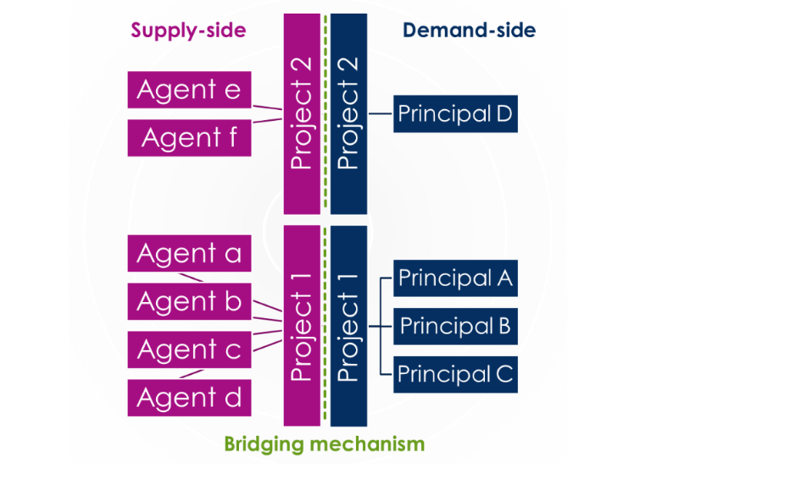

Demanders  
(Principals)

Demand Pool

Suppliers  
(Agents)

Supply Pool

Blockchain Transaction Record

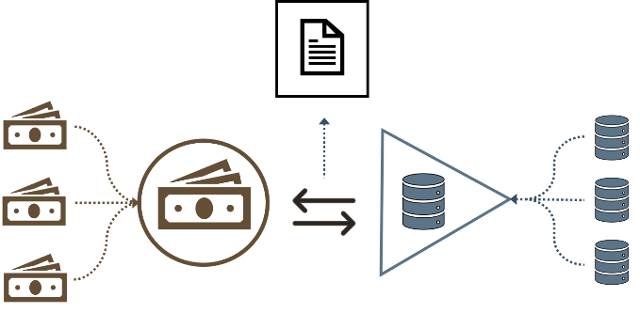

**Figure 2:** simplified KARANG schematic, emphasizing pooling mechanism

The appropriate form of a theoretical model that represents the KARANG concept is not immediately obvious. This project proposes to use a contract theory model governing the production of threshold quasi-public projects that incorporates adverse selection and moral hazard on both the demand and supply side. The term “quasi-public” is used here to refer to the possibility that not all projects produce direct benefits to all network members, but rather a subset[10]. To make model development more manageable, the overall model will be broken own into three separate parts, developed sequentially: 1) a demand-side model where multiple principals benefit from the outputs of multiple threshold quasi-public projects, 2) a supply-side model based on multiple agents who contribute towards the completion of multiple threshold quasi-public projects, and a bridging mechanism which connects the supply and demand side models together (see Figure 3). Both models will incorporate a pooling mechanism to aggregate dilute demand/supply from among the principals/agents, and thus allow the threshold levels for the quasi-public good to be reached. Attempts will be made to identify any optimal interior and boundary solutions to these models separately and joined, as well as their associated necessary conditions. Importantly, the relative gains/losses to principals, agents, and society as a whole with KARANG in place versus without will be examined under four different states: A) perfect information, B) adverse selection only, C) moral hazard only, and D) both adverse selection and moral hazard.

### Empirical validation phase:

This phase will focus on empirically validating the theoretical model designed in the first phase by conducting a lab-based simulation under a controlled setting. This phase can be further broken down into three steps: 1) Designing a lab experiment that emulates the interactions and incentive structures built into the theoretical model, 2) recruiting human participants to take part in the experiment, and 3) executing a sufficient number of experimental trials, analyzing the results, and comparing these results against the expected results predicted by the theoretical model. Experimental design as well as recruitment strategies will follow the recommendations outlined in the experimental economics literature[11]. The lab experiment will take place at the University of Washington (UW) in Seattle, and invite students and surrounding community members to take part in the study. As such, all UW research study protocols will be followed as required. Experimental results will be analyzed both qualitatively and quantitatively; identifying any trends in the data and statistical significance. Comparisons between empirical results and theoretical predictions will be made using appropriate statistical tests.

## Outputs & outcomes

Each of the two phases of this project will produce several outputs. The first phase, Theoretical, will produce one large model for the KARANG concept consisting of two sub-models and a bridging mechanism. These models will be thoroughly analyzed in order to produce at least one, if not three[12], distinct papers which will be published in a relevant academic journal. The second phase will result in a series of lab experiments and associated analysis of results. This analysis will either be added to the theory paper(s), or written up as a distinct empirical paper in its own right. Further, the insights gained from the process of designing and analyzing these models, and conducting these experiments will be shared among colleagues in the economics and fisheries departments at the University of Washington as part of the various presentation opportunities these departments provide to graduate students. The publication(s) will be shared more formally through participation in one or two economic and/or fisheries conferences[13]. In addition to these formal publications, four blog posts will be written up sequentially, one after the completion of each sub-model, the overall model, and the experimental phase. All analysis will be done using either Stata: Statistical software for data science or R; and thus the publications and blog posts will include a link to a public project on GitHub where all code files and datasets will be available for others to use. Finally, this research will provide the foundation for another project that will continue empirical validation through piloting a basic KARANG network in a real coastal community. Thus, this project will pave the way towards the eventual implementation of a holistic solution that has the potential to revolutionize our blue economy.

## Timeline

|  |  |
| --- | --- |
| Spring / Summer 2023 | * + Develop demand model   + Write potential academic paper on demand model   + Write blog about demand model |
| 2024 | * + Develop supply model   + Write potential academic paper on supply model   + Write blog about supply model   + Develop bridge mechanism |
| Summer 2024 | * + Write academic paper on overarching model   + Write blog about overarching model   + Design empirical study |
| 2025 | * + Acquire participants   + Conduct experimental trials   + Analyze results & compare with theoretical predictions |
| Summer 2025 | * + Write potential empirical paper   + Write blog about empirical findings |

## References

[1] *Fact Sheet - United Nations*. <https://www.un.org/sustainabledevelopment/wp> content/uploads/2017/05/Ocean-fact-sheet-package.pdf.

[2] “What Does the World Eat?” *Sustainable Fisheries UW.* Accessed November 13, 2020. <https://sustainablefisheries-uw.org/seafood-101/what-does-the-world-eat/>.

[3] Rowland, Michael Pellman. “Two-Thirds Of The World's Seafood Is Over-Fished -- Here's How You Can Help.” *Forbes, Forbes Magazine*, 25 July 2017, www.forbes.com/sites/michaelpellmanrowland/2017/07/24/seafood-sustainability-facts/#3c1a89934bbf.

[4] Podlaha, Adam, et al. “Weather, Climate & Catastrophe Insight.” *AON*, 2019, thoughtleadership.aonbenfield.com/Documents/20190122-ab-if-annual-weather-climate-report-2018.pdf.

[5] Huizen, Jennifer. “Oceans Could Lose $1 Trillion in Value Due to Acidification.” *Scientific American*, 21 Oct. 2014, www.scientificamerican.com/article/oceans-could-lose-1-trillion-in-value-due-to-acidification/.

[6] From numerous personal interviews with coastal government and academic researchers, NGOs, and companies.

[7] “Anaconda | State of Data Science 2020.” *Anaconda.* Accessed November 13, 2020. <https://www.anaconda.com/state-of-data-science-2020>.

[8] Wilder-James, Edd. “Breaking Down Data Silos.” *Harvard Business Review*, 22 Feb. 2017, hbr.org/2016/12/breaking-down-data-silos.

[9] J.J. Laffont, J. Tirole, Privatization and incentives, J. Law, Econ., Organ. 6 (1991) 1–32.

[10] D. Martimort, Multi-pricipaux avec anti-selection, Ann. Econ. Statist. 28 (1992) 1–38.

[11] D. Martimort, Exclusive dealing, common agency, and multiprincipals incentive theory, RAND J. Econ. 27 (1996) 1–31.

[12] C. Mezzetti, Common agency with horizontally differentiated principals, RAND J. Econ. 28 (1997) 323–345.

[13] L. Stole, Mechanism design under common agency: theory and applications, Working paper, GSB, University of Chicago, 1997.

[14] B. Biais, D. Martimort, J.-C. Rochet, Competing mechanisms in a common value environment, Econometrica 68 (2000) 799–838.

[15] D. Martimort, L. Stole, The revelation and delegation principles in common agency games, Econometrica 70 (2002) 1659–1674.

[16] M. Peters, Common agency and the revelation principle, Econometrica 69 (2001) 1349–1372.

[17] M. Peters, Negotiation and take-it-or-leave-it in common agency, J. Econ. Theory 111 (2003) 88–109.

[18] B.D. Bernheim, M.D. Whinston, Common marketing agency as a device for facilitating collusion, RAND J. Econ. 16 (1985) 269–281.

[19] B.D. Bernheim, M.D. Whinston, Common agency, Econometrica 54 (1986) 923–943.

[20] R. Townsend, Optimal contracts and competitive markets with costly state verification, J. Econ. Theory 21 (1979) 265–293.

[21] D. Gale, M. Hellwig, Incentive-compatible debt contracts: the one-period problem, Rev. Econ. Stud. 52 (1985) 647–663.

[22] K. Border, J. Sobel, Samurai accountant: a theory of auditing and plunder, Rev. Econ. Stud. 54 (1987) 525–540.

[23] D. Martimort, L. Stole, Contractual externalities and common agency equilibria, Advances Theoretical Econ. 3 (2003) Article 4.

[24] I. Segal, Contracting with externalities, Quart. J. Econ. 114 (1999) 337–389.

[25] A. Shleifer, R. Vishny, Large shareholders and corporate control, J. Polit. Economy 94 (1986) 461–488.

[26] M. Pagano, A. Röell, The choice of stock ownership structure: agency costs, monitoring, and the decision to go public, Quart. J. Econ. 113 (1998) 187–226.

[27] X. Freixas, J.-C. Rochet, Microeconomics of Banking, MIT Press, Cambridge, MA, 1997.

[28] J. Tirole, Financial Crises, Liquidity, and the International Monetary System, Princeton University Press, Princeton, NJ, 2002.

[29] M. Dewatripont, E. Maskin, Credit and efficiency in centralized and decentralized economies, Rev. Econ. Stud. 60 (1995) 35–52.

[30] M. Hellwig, Banking, financial intermediation and corporate finance, in: A. Giovannini, C. Mayer (Eds.), European Financial Integration, Cambridge University Press, Cambridge, 1991, pp. 35–63.

[31] R. Rajan, Insiders and outsiders: the choice between informed and arm’s length debt, J. Finance 47 (1992) 1367–1400.

[32] E. Detragiache, P. Garella, L. Guiso, Multiple versus single banking relationships: theory and evidence, J. Finance 55 (2000) 1385–1403.

[33] P. Bolton, D.S. Scharfstein, Optimal debt structure and the optimal number of creditors, J. Polit. Economy 104 (1996) 1–25.

[34] E. Carletti, The structure of bank relationship, endogenous monitoring, and loan rates, J. Finan. Intermediation 13 (2004) 58–86.

[35] Li, Z., Anderson, C. M., & Swallow, S. K. (2016). Uniform price mechanisms for threshold public goods provision with complete information: An experimental investigation. *Journal of Public Economics*, *144*, 14–26. https://doi.org/10.1016/j.jpubeco.2016.09.004

[36] Khalil, F., Martimort, D., & Parigi, B. (2007). Monitoring a common agent: Implications for financial contracting. *Journal of Economic Theory*, *135*(1), 35–67. <https://doi.org/10.1016/j.jet.2005.08.010>

1. Converted to the value of USD in 2020.
2. existing in-water observatories only cover 9–15% of global ocean surface.
3. For example, a single oceanic pH sensor can cost between $ 5,000-50,000 depending on the exact use-case, while the government coral reef monitoring budget in Malaysia is just $20 per hectare, and less than 1¢ per hectare in Indonesia. For perspective, adequate reef patrols are estimated to cost over $4,500 per hectare per year. Coastal areas already spend over $26 billion annually on data analytics. But only a fraction of these funds end up used to analyze coastal threats. 45% of data scientists’ time is spent on data gathering and preparation, 80% of business leaders view poor systems/applications integration as a top problem, system administrators face daunting IT security standards, and developers are burdened by the re-coding requirements involved in production [7, 8].
4. Applications already span several fields. Laffont and Tirole [9] analyze regulation; Martimort [10,11], Mezzetti [12] and Stole [13] deal with nonlinear pricing and manufacturer–retailer relationships; Biais et al. [14] study competing marketmakers in financial markets. Martimort and Stole [15] and Peters [16,17] offer theoretical frameworks to understand what are the natural classes of mechanisms to be studied. For models of common agency under moral hazard, see Bernheim and Whinston [18,19] among others.
5. For example, in a moral hazard setting, indebtedness is higher when the agent borrows from multiple principals than if the agent could only borrow from one.
6. For instance, Martimort and Stole [23] analyze a common retailer–manufacturer example. See also the more abstract framework of Peters [17] who stresses the role of direct externalities between the principal on the kind of mechanisms which can be used. Segal [24] offers a framework for dealing with contractual externalities under complete information but reverses the role of the principal and the agents.
7. For example, clean water is an essential component of (among many things) property values, tourism potential, and fisheries production; mangrove forests function as erosion prevention and a native food source; aquatic monitoring data is used to ensure public health and safety, and further scientific knowledge; and beach restoration benefits tourists, residents, and local wildlife.
8. The term “quasi” refers to goods/services that are not necessarily fully public, but simply generate benefits to multiple parties. For example, the rearing conditions data specific to a certain farmed shrimp product is valuable to the farmer, the supply chain, and the consumer; but not to the boat shop next door.
9. Examples of possible goods and services include: the installation and maintenance of, and resultant data stream from a continuous aquatic monitoring system, rearing condition information associated with a batch of farmed shrimp, vessel tracking and logbook data required by the government in order to maintain a fishing license, records of mangrove forest rehabilitation activity required by a funding or insurance agency, etc.
10. For example, demanders 1-3 desire good X and demanders 2-4 desire good Y, thus demander 1 gets zero direct benefit from good X and demander 4 gets zero direct benefit from good Y.
11. See (*The Handbook of Experimental Economics, Volume 2*, 2016) and (*Experimental Economics by Douglas D. Davis, Charles A. Holt - Google Play*, n.d.)
12. One paper for the demand-side, one for the supply-side, and one for the overarching model which connects supply and demand together so that both are endogenously-determined.
13. Potential conferences include: the American Economic Association Annual Meeting; International Institute of Fisheries Economics & Trade Conference, Markets; Contracts and Organizations Conference sponsored by Australian National University; and the United Nations Oceans Conference.